|  |
| --- |
| **SKULLCRATE** |

**MAKE YOUR BRAND WITH US**

|  |
| --- |
| **[@printondemand.skullcrate](https://www.instagram.com/printondemand.skullcrate)** |

|  |
| --- |
| **MINIMUM ORDER QUANTITY**  **10 PIECE ONLY-/** |
| |  |  |  |  |  |  | | --- | --- | --- | --- | --- | --- | | |  | | --- | | **PRINT** | | |  | | --- | | **@printondemand.skullcrate** | | |  | | --- | | **DEMAND** | | |

|  |  |  |  |  |
| --- | --- | --- | --- | --- |
| |  | | --- | | **DTF PRINT RATE CHART** | | | | |
| **PRINT SIZE** | | **PRICE** |  |
| A4 SIZE PRINT | | ₹ 85 -/ |
| A3 SIZE PRINT | | ₹ 135 -/ |
| A2 SIZE PRINT | | ₹ 240 -/ |
| CHEST LOGO | | ₹ 20 -/ |
| PRINT | |
| NECK BRAND TAG | | ₹ 5 -/ |
| |  | | --- | | **DIMENSION** | | | | |
| A4 SIZE | (8.3 X 11.7 inches) | | |
| A3 SIZE | (11.7 X 16.5 inches) | | |
| A2 SIZE | (16.5 X 23.3inches) | | |
| CHEST LOGO | | (3.5 x 3.5 inches) | |

**WE ALSO PROVIDE DTF SHEET**

|  |
| --- |
| **FOR MORE DETAILS CONTACT (+91 8826946011)** |

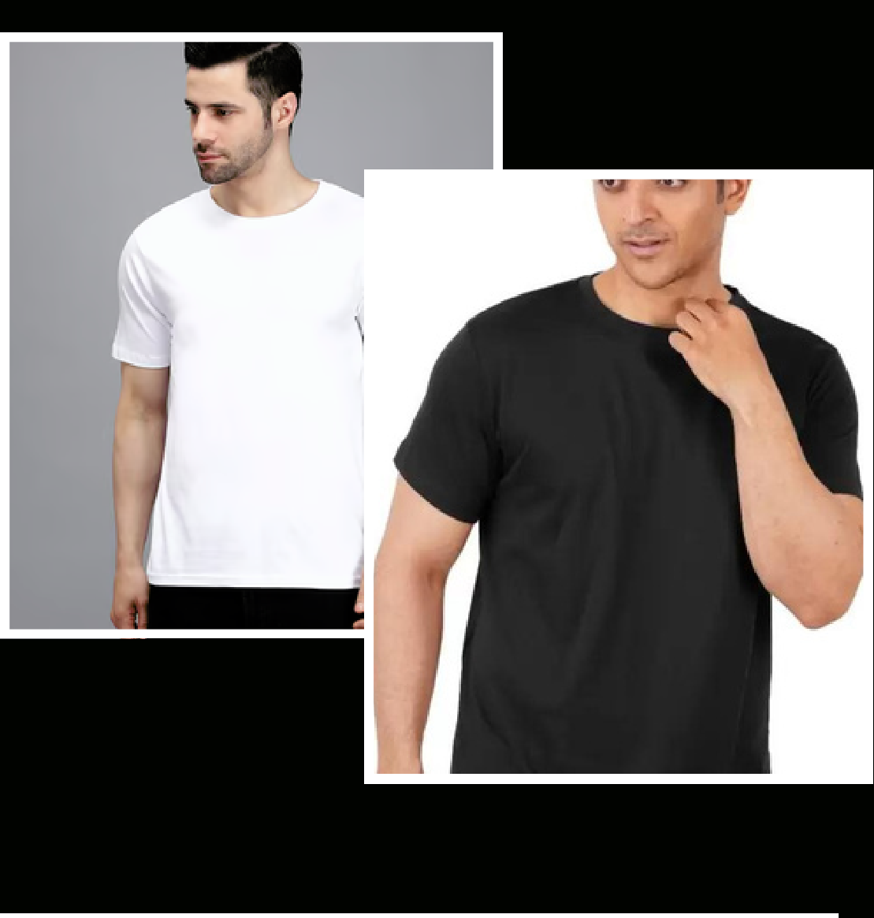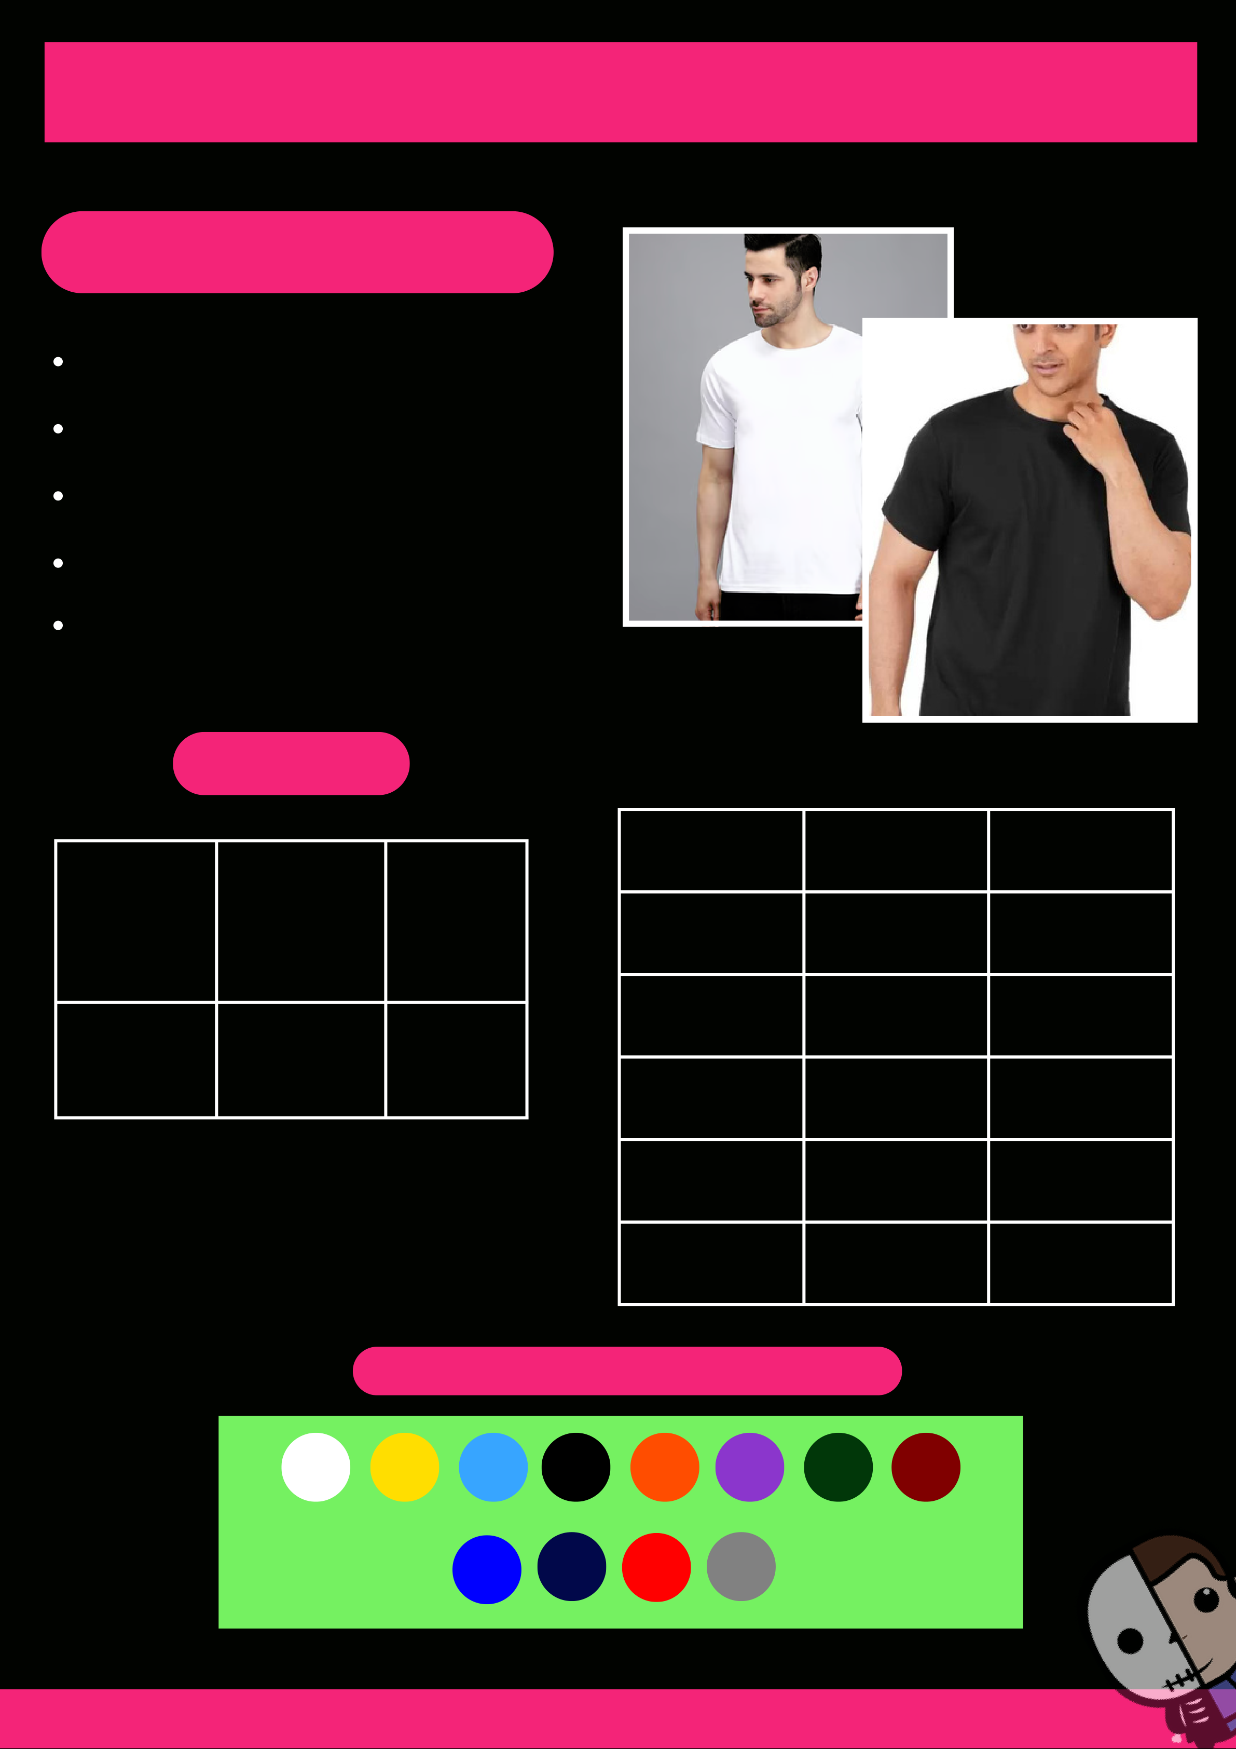

**COTTON BIOWASH T-SHIRT**

**PRODUCT QUALITY**   
 **100 % COTTON**

**180-200 GSM**

**BIO-WASHED**

**SUPER COMBED COTTON**

**NO COLOUR FADING**

|  |  |  |  |  |  |
| --- | --- | --- | --- | --- | --- |
| **PACK OF 10** | **PRICES** | SAMPLE | SIZE | **SIZE CHART** | **LENGTH** |
| **CHEST** |
| **PACK OF 30** | **S** | 38 | **26** |
| PRICE |
| ₹ 170 -/ | ₹ 160 -/ | ₹ 220 -/ |
| M | 40 | 27 |
| L | 42 | 28 |
| XL | 44 | 29 |
| XXL | 46 | 30 |

**COLOURS AVAILABLE**

|  |  |  |  |  |  |  |  |
| --- | --- | --- | --- | --- | --- | --- | --- |
| **WHITE** | **YELLOW** | **SKY BLUE** | **BLACK** | **ORANGE** | **LAVENDER** | **DARK GREEN** | **MAROON** |

|  |  |  |  |
| --- | --- | --- | --- |
| **BLUE** | **NAVY BLUE** | **RED** | **GREY** |

**FOR MORE DETAILS CONTACT (+91 8826946011)**

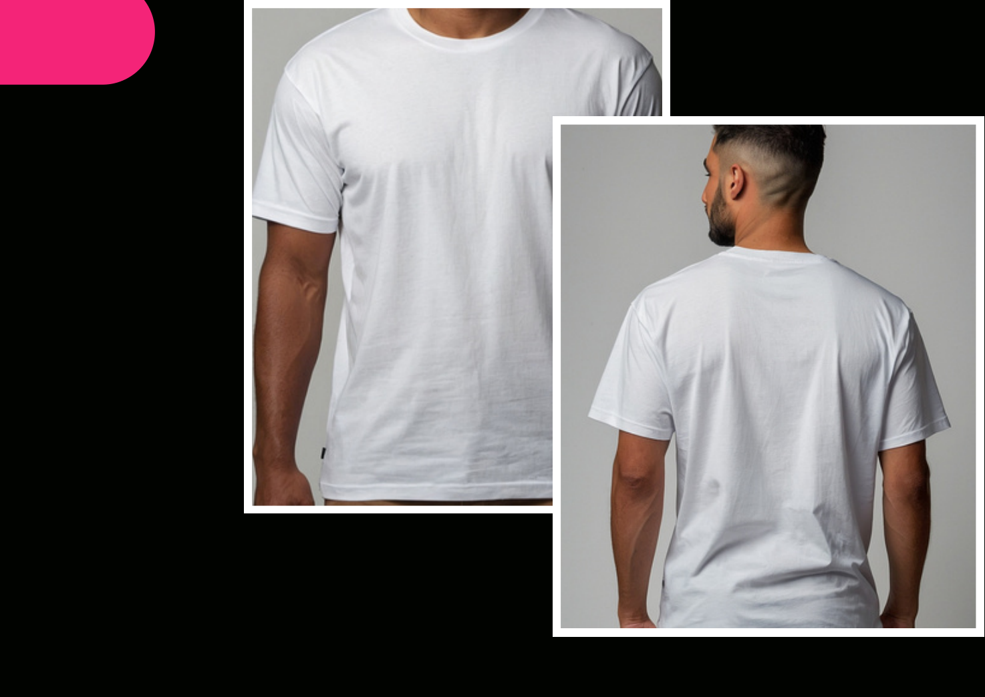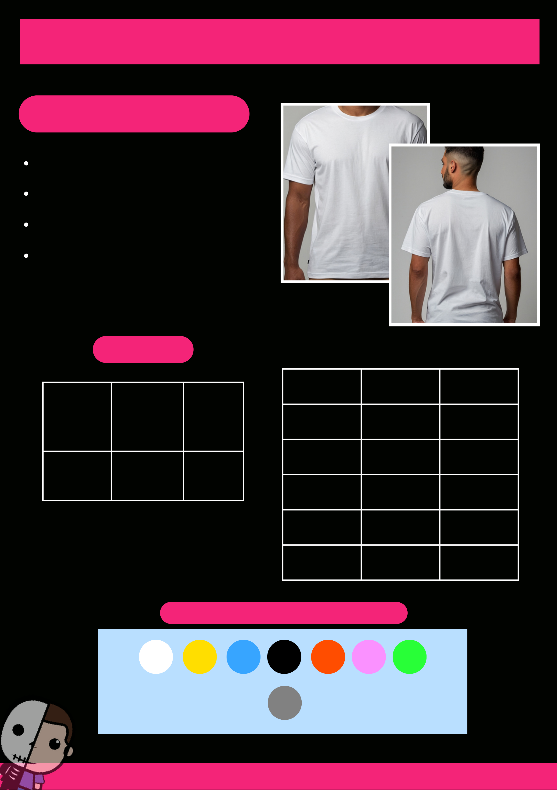

**PC COTTON T-SHIRT**

**PRODUCT QUALITY**

**60 % COTTON 40% PC**   
**200 GSM**   
**FEEL GOOD FABRIC**   
**NO COLOUR FADING**

**PRICES**  **SIZE CHART**

|  |  |  |  |  |  |
| --- | --- | --- | --- | --- | --- |
| **PACK OF 10** | **PACK OF 30** | SAMPLE | SIZE | **CHEST** | **LENGTH** |
| **S** | 38 | **26** |
| PRICE |
| ₹ 150 -/ | ₹ 140 -/ | ₹ 200 -/ | M | 40 | 27 |
| L | 42 | 28 |
| XL | 44 | 29 |
| XXL | 46 | 30 |

**COLOURS AVAILABLE**

|  |  |  |  |  |  |  |
| --- | --- | --- | --- | --- | --- | --- |
| **WHITE** | **YELLOW** | **SKY BLUE** | **BLACK** | **ORANGE** | **PINK** | **LOGHT** |
| **GREEN** |

**GREY**

**FOR MORE DETAILS CONTACT (+91 8826946011)**

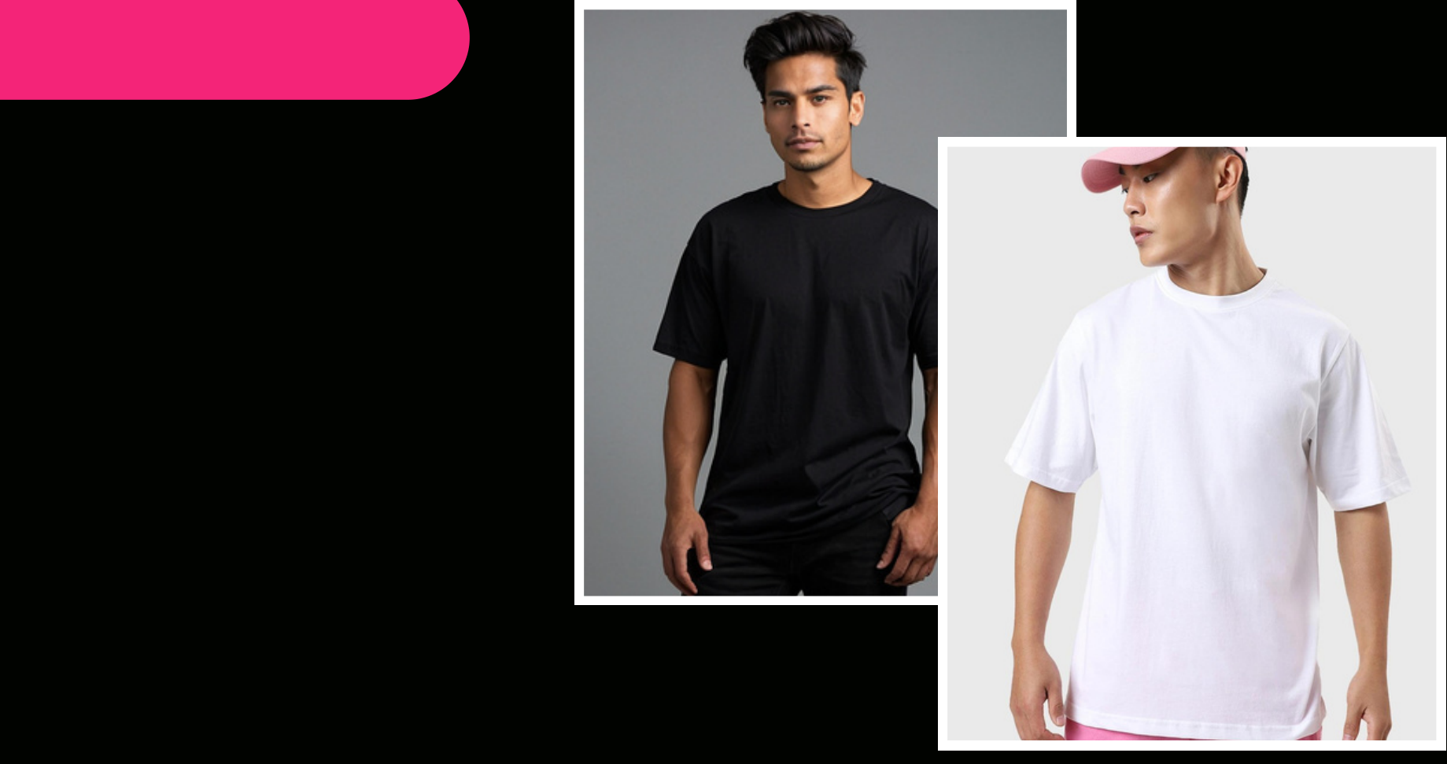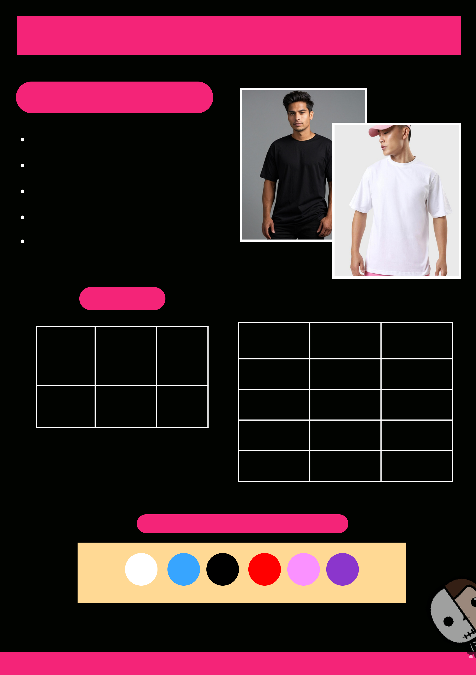

**OVERSIZE T-SHIRT**

**PRODUCT QUALITY**

**100 % COTTON**   
**200-220 GSM**   
**BIO-WASHED**   
**SUPER COMBED COTTON**   
**NO COLOUR FADING**

**PRICES**  **SIZE CHART**

|  |  |  |  |  |  |
| --- | --- | --- | --- | --- | --- |
| **PACK OF 10** | **PACK OF 30** | SAMPLE | SIZE | **CHEST** | **LENGTH** |
| PRICE |
| ₹ 230 -/ | ₹ 220 -/ | ₹ 280 -/ | **S** | 41 | **27.5** |
| M | 44 | 28.5 |
| L | 47 | 29.5 |
| XL | 50 | 30.5 |

**COLOURS AVAILABLE**

|  |  |  |  |  |  |
| --- | --- | --- | --- | --- | --- |
| **WHITE** | **SKY BLUE** | **BLACK** | **RED** | **PINK** | **LAVENDER** |

**FOR MORE DETAILS CONTACT (+91 8826946011)**

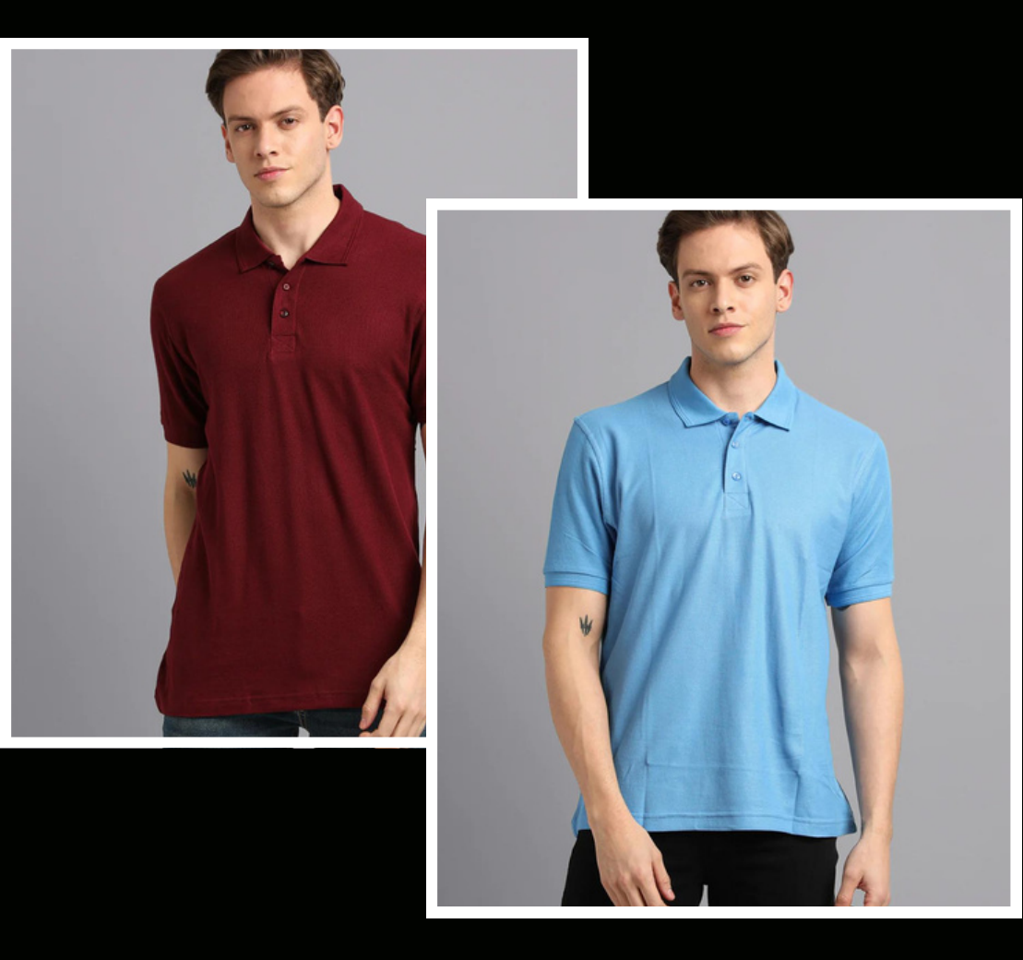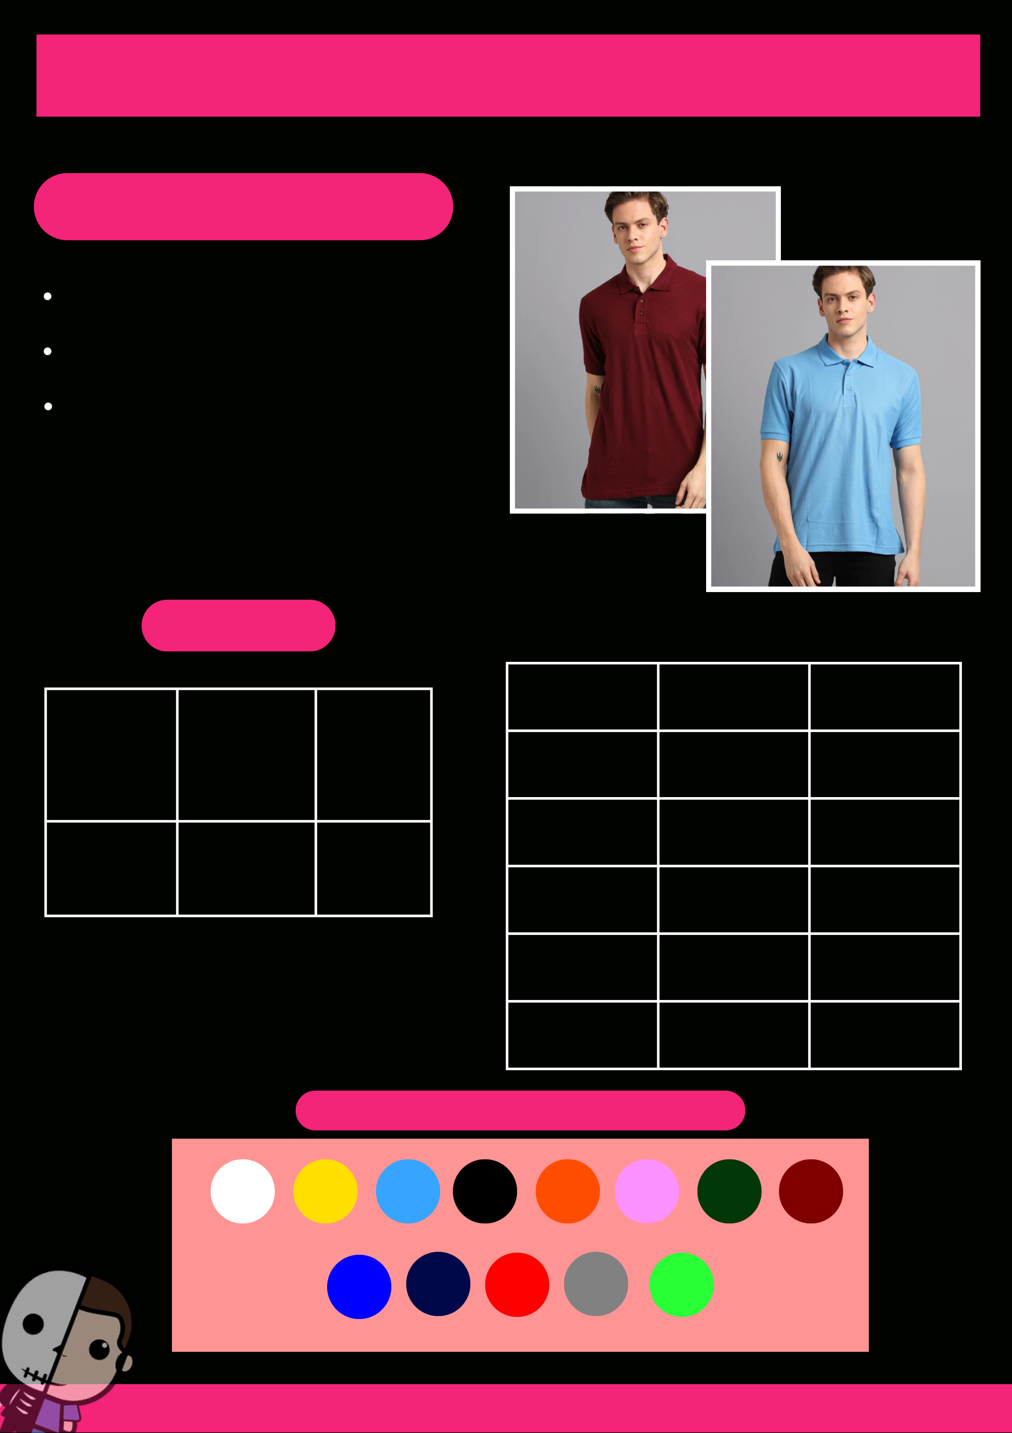

**POLO T-SHIRT (MATTY) PRODUCT QUALITY**

**FABRIC -MATTY**

**200 GSM**

**NO COLOUR FADING**

**PRICES SIZE CHART**

|  |  |  |  |  |  |
| --- | --- | --- | --- | --- | --- |
| **PACK OF 10** | **PACK OF 30** | SAMPLE | SIZE | **CHEST** | **LENGTH** |
| **S** | 38 | **25** |
| PRICE |
| ₹ 170 -/ | ₹ 160 -/ | ₹ 210 -/ |
| M | 40 | 26 |
| L | 42 | 27 |
| XL | 44 | 28 |
| XXL | 46 | 29 |

**COLOURS AVAILABLE**

|  |  |  |  |  |  |  |  |
| --- | --- | --- | --- | --- | --- | --- | --- |
| **WHITE** | **YELLOW** | **SKY BLUE** | **BLACK** | **ORANGE** | **PINK** | **DARK GREEN** | **MAROON** |

|  |  |  |  |  |
| --- | --- | --- | --- | --- |
| **BLUE** | **NAVY BLUE** | **RED** | **GREY** | **LOGHT** |
| **GREEN** |

**FOR MORE DETAILS CONTACT (+91 8826946011)**

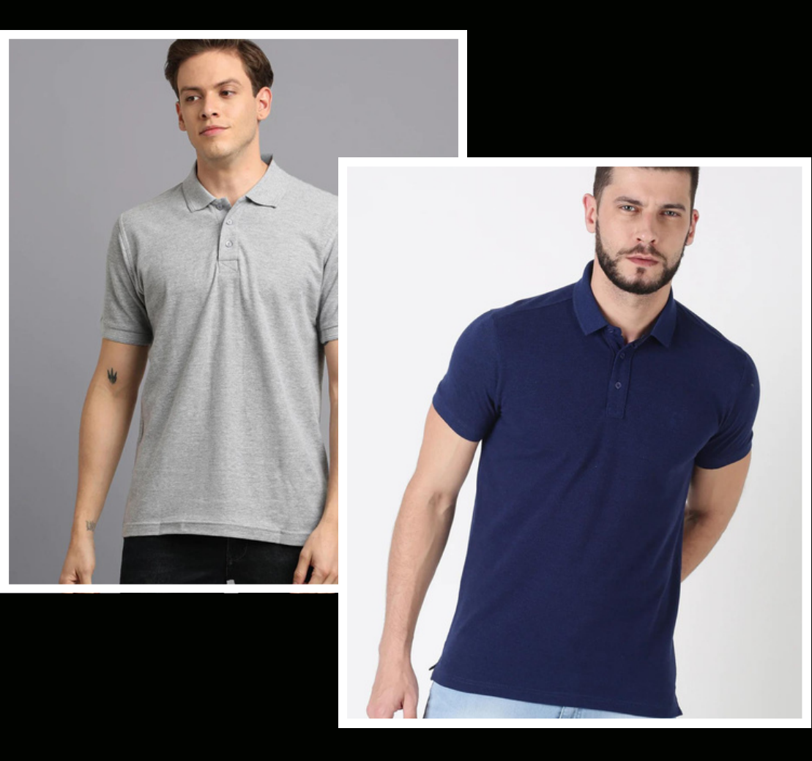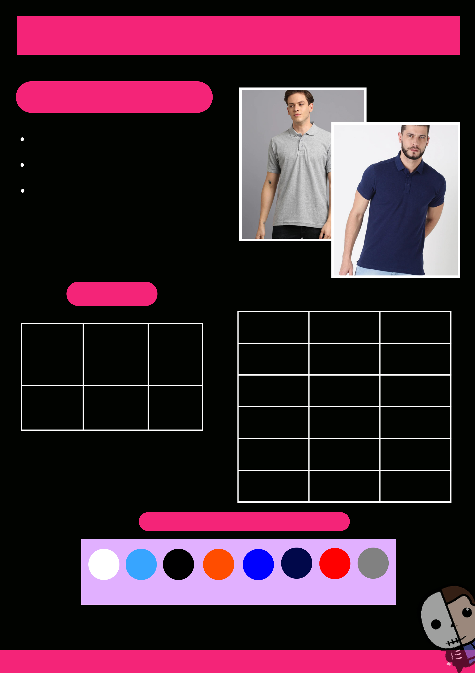

**POLO T-SHIRT (PC MATTY) PRODUCT QUALITY**

**FABRIC - PC MATTY**

**250 GSM**

**NO COLOUR FADING**

**PRICES SIZE CHART**

|  |  |  |  |  |  |
| --- | --- | --- | --- | --- | --- |
| **PACK OF 10** | **PACK OF 30** | SAMPLE | SIZE | **CHEST** | **LENGTH** |
| **S** | 38 | **26** |
| PRICE |
| ₹ 270 -/ | ₹ 260 -/ | ₹ 310 -/ |
| M | 40 | 27 |
| L | 42 | 28 |
| XL | 44 | 29 |
| XXL | 46 | 30 |

**COLOURS AVAILABLE**

|  |  |  |  |  |  |  |  |
| --- | --- | --- | --- | --- | --- | --- | --- |
| **WHITE** | **SKY BLUE** | **BLACK** | **ORANGE** | **BLUE** | **NAVY BLUE** | **RED** | **GREY** |

**FOR MORE DETAILS CONTACT (+91 8826946011)**